5Ref: DGR/JB

Date 18th January 2018

Dear Sir and Brother,

The Right Worshipful Provincial Grand Master will be hosting a Luncheon in honour of those Brethren who have been Appointed to and Promoted in Grand Rank. The Luncheon will take place in the Elizabethan Room of the Imperial Hotel, Russell Square, London, prior to the Meeting of Grand Lodge on Wednesday 25th April 2018. Cocktails at 12.15pm for 12.45pm.

Brethren from this Province proposing to attend the Investiture and wishing to join the Right Worshipful Provincial Grand Master's party will be most welcome to do so, at a fee of £40.00 inclusive of table wine (excluding cocktails and liqueurs). Names must be submitted to the Provincial Office no later than the 6th April 2018. Cheques will be refunded to those who fail to obtain admission tickets to the Investiture, provided this office is informed no later than this date.

Historically, a limited number of single and twin bedrooms (with bathrooms) have been made available at the President and Imperial Hotels, Russell Square, for the nights of the 24th, 25th and 26th April 2018 and any bookings should be negotiated by applicants direct online at www.imperialhotels.co.uk and/or by telephoning the Hotel direct on 020 7837 8844.

Please utilize the enclosed form to attend the Provincial Grand Master's Luncheon.

Yours sincerely and fraternally,

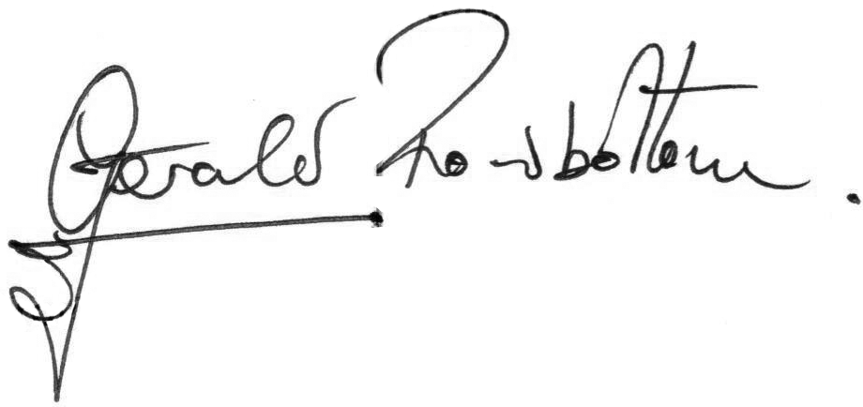

Provincial Grand Secretary

To be returned to:
John Bamsey, 128 Newport Road, CARDIFF, CF24 1DH
By 6 ^{th} April 2018, at the latest.

I wish to join the PGM’s Luncheon Party on 25th April 2018
and enclose fee of £40.00 per person.
Name: ………………………………………………………………………………….
Rank: ………………………………………………………………………………….
Lodge: ………………………………………………………………………………….
Guest1: ...……………………………………………………………………………….
Rank: ………………………………………………………………………………….
Lodge: ………………………………………………………………………………….
Guest2: ...……………………………………………………………………………….
Rank: ………………………………………………………………………………….
Lodge: ………………………………………………………………………………….
If possible, please arrange seating near: ……………………………………………
Cheque enclosed £ ……………………..
(PLEASE PRINT)

Luncheon reservations will only be accepted when accompanied by an appropriate Cheque made payable to ‘P.G.L. Dining’
Please do not include payment for Accommodation, as this should be settled direct with the Hotel prior to your departure.

