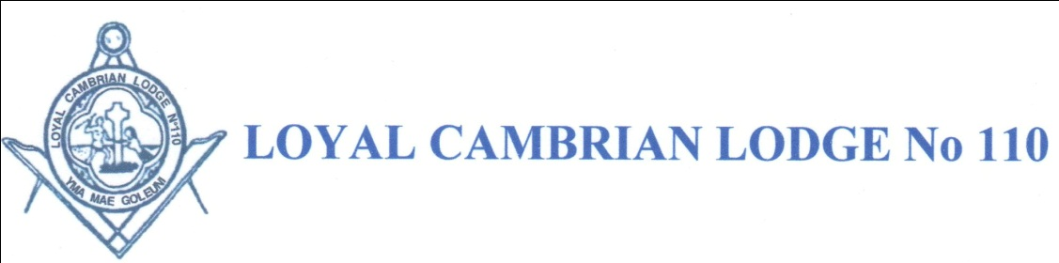
Loyal Cambrian Lodge No. 110 will host a meeting at the Merthyr Tydfil Masonic Hall (7 Park Terrace, Merthyr Tydfil, CF47 8RF. Tel: 01685 723610) on 4th February 2016 to celebrate the achievements of the Province in the first year of the 2021 Festival.
The Lodge will open at 6.30pm. Visitors received 6.40p.m.
The Provincial Grand Master, R.W.Bro. Gareth Jones OBE,
and W.Bro. Sir Paul M. Williams OBE DL KStJ PJGD will be in attendance.
Every Worshipful Master and Charity Steward of those Lodges who have achieved a Gold, Silver and Bronze will be invited to receive their Lodge Award.
W.Bro. Sir Paul M. Williams OBE DL KStJ PJGD will address the meeting.
The meeting will be followed by a Festive Board with light entertainment.
……………………..PLEASE DETACH…………………………
SEND YOUR RESERVATION WITH NAMES OF GUESTS AND PAYMENT TO LOYAL CAMBRIAN LODGE SECRETARY:
W.Bro. Robert Rees, 4 Chapel Banks, Georgetown, Merthyr Tydfil, CF48 1BP or reply by email to robert_rees110@msn.com.
PLEASE REPLY BEFORE MONDAY 11th January 2016. NO MEAL WILL BE RESERVED UNLESS RESERVATION IS RETURNED COMPLETE WITH PAYMENT.
MENU
TOMATO and BASIL SOUP
ROAST BEEF
Served with Seasonal Vegetables
SELECTION of GATEAX
CHEESE BOARD & BISCUITS
COFFEE/TEA
£11.00 per person
From W.Bro./Bro.................................................................................Lodge No………………
Tel No…………………………….email.………………………………………………………
My guest(s) W.Bro./Bro...............................................................................................................
Any special dietary requirements.................................................................................................
There will be limited numbers so please book early to avoid disappointment

